TASK 15- NAT GATEWAY

1. VPC CREATED

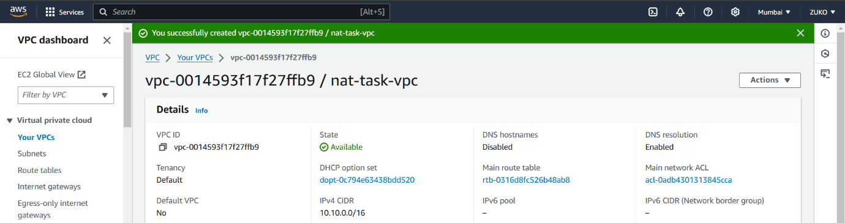

1. CREATE IGW AND ATTACH TO VPC.

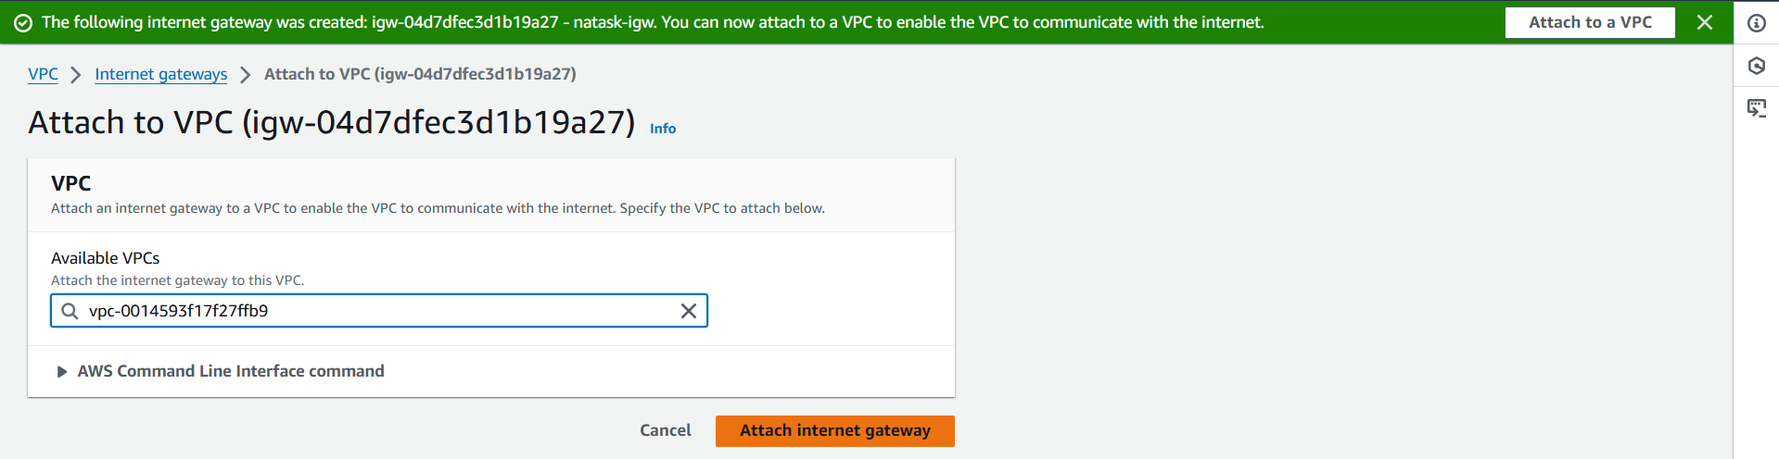

1. CREATE PUB & PVT SUBNETS

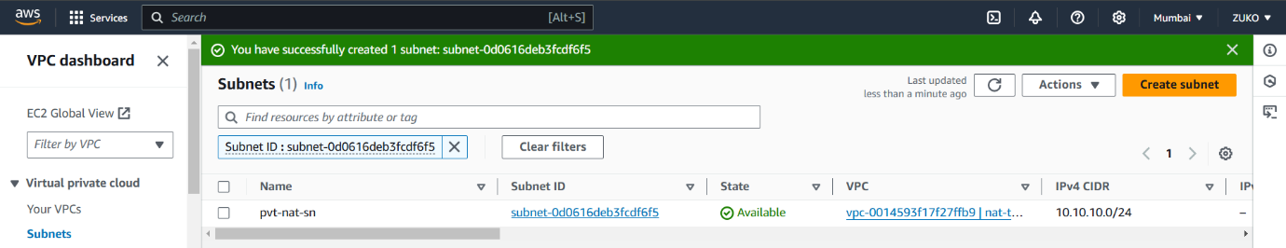

1. CREATE PUB RT & PVT RT

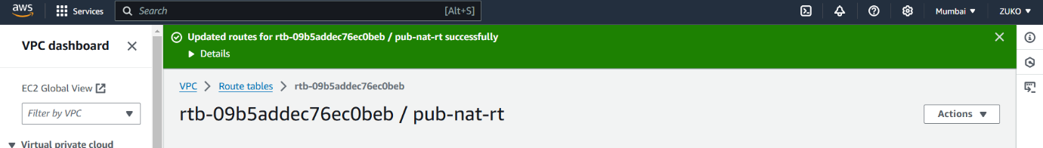

5. CREATE NAT GATEWAY

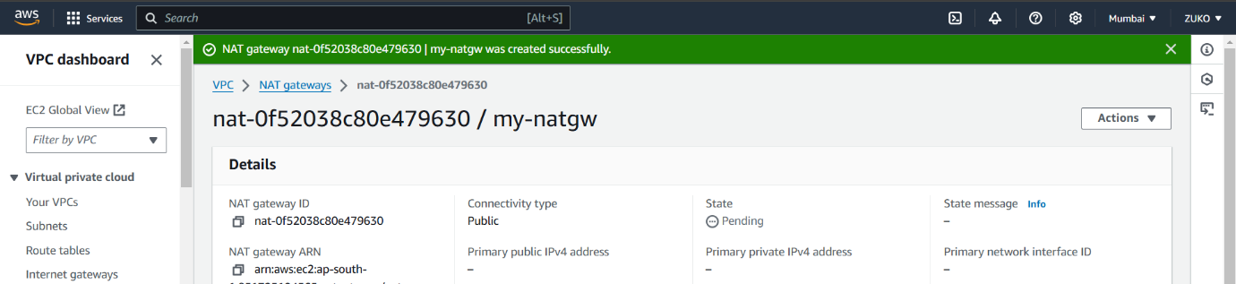

1. ASSOCIATE SUBNETS & EDIT ROUTES PUB RT TO IGW AND PVT RT WITH NAT GW

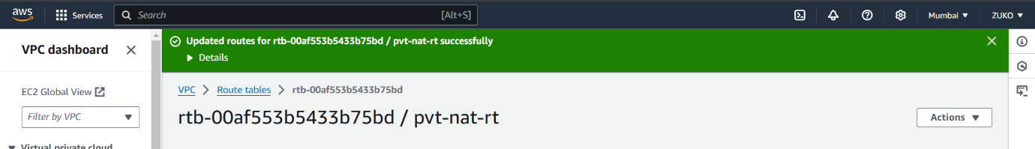

1. CREATE TWO EC2 INSTANCES IN THE SAME VPC BUT IN BOTH SUBNET EACH AND CONNECT TO PUB-SN INSTANCE VIA PUTTY

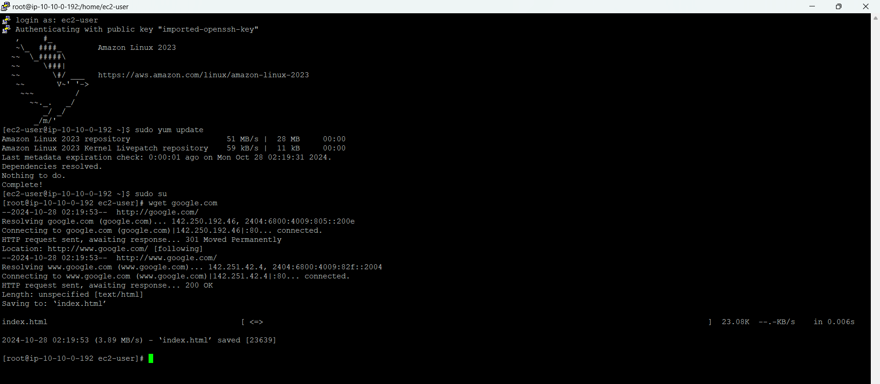

1. CREATE A FILE AND SAVE PRIVACY ENHANCED MAIL TO IT AND PROVIDE PERMISSIONS.

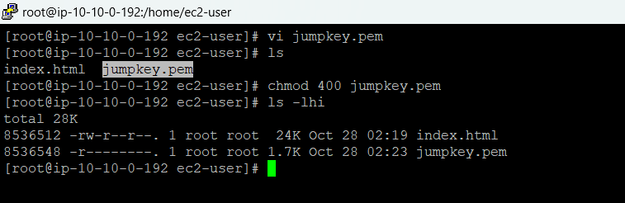

1. SUCCESFUL JUMP TO PVT-SN INSTANCE

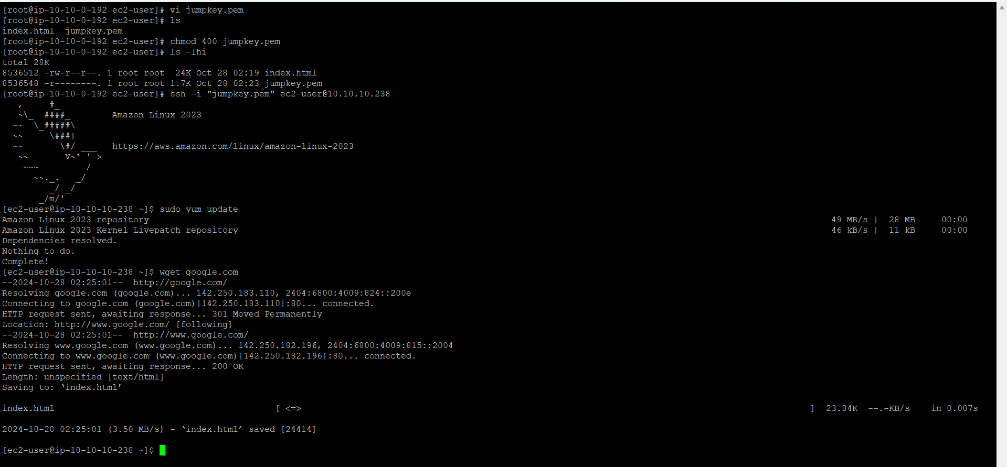

1. INSTALLED GIT TO CHECK INTERNET CONNECTION VIA NAT GATEWAY.

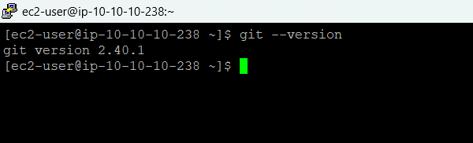

1. JUMPING FROM PVT-SN INSTANCE TO PUB-SN INSTANCE.

